

NAVFIT98A

Frequently Asked Questions

For

Version 2.2.0.33

August 20, 2025

Unclassified

Document Change History
Version | Date | Drafted by | Change Type | Change Description
1.0 | 03/11/2025 | Kenneth Tillman | Initial Document. | New Software Version.
1.1 | 3/24/2025 | Kenneth Tillman | Update | Changes following lessons Learned from V32 installations
1.2 | 4/11/2025 | Kenneth Tillman | Update | Added the .Net Framework information
1.3 | 4/30/2025 | Kenneth Tillman | Updated | Added 2 questions to support Part 2 in Software Center
1.4 | 5/27/2025 | Kenneth Tillman | Updated | Updated for final v33 build dtd 5/27/2025
1.5 | 7/23/2025 | Kenneth Tillman | Updated | Added SR Rater Address issue and Can’t find Folder error
1.6 | 7/24/2025 | Kenneth Tillman | Updated | Added questions about Shared Computers
1.7 | 7/25/2025 | Multiple | Updated | Updated again for v33
1.8 | 7/28/2028 | Multiple | Updated | Changed misspellings and added detail for users to download/request software
1.8 | 8/6/2025 | Ken Tillman | Updated | Added additional questions identified after a False Positive Virus was identified by one user.
1.9 | 8/8/2025 | Ken Tillman | Update | changed item 27. The Updated instructions are in item 29. Also redacted some fake names and SSNs at the request of MNP
2.0 | 8/15/2025 | Ken Tillman | Update | Made changes to support production support issues and additional changes
2.1 | 8/20/2025 | Ken Tillman | Update | Made changes to support additional changes not found on last build. Also updated the Known Issues block to indicate things that were corrected from the original release.

Table of Contents
1. How do I get NAVFIT98A? 1
2. How do I download the NAVFIT98A Program onto my personal computer? 1
3. How do I download the NAVFIT98A Program on my Nautilus computer? 2
4. How do I download the NAVFIT98A Program on my NMCI computer? 2
5. How do I access NAVFIT98A through NVD? 2
6. How do I get access to the NAVFIT98A Program on a Government provided computer without downloading the software? 3
7. How do I download the NAVFIT98A Program on Non-NMCI, USMC, USA, USAF or other Government provided computers? 3
8. Which copy of the Installation package should I install? 4
9. Right after installing the software, I get the following error: 4
10. Right after installing the software, I get the following error: 5
11. Do I need to run the “NAVFIT98A Part 2 Access Database” from Software Center? 5
12. When I install the software or run the software, a popup box shows that says “.Net Framework v4.8.1 is needed”. 5
13. Can I use an existing Database with this Version 6
14. Why does the printed copy and NAVFIT98A program summary group average differ? 6
15. When I print the summary letter, I get an error “a folder must have a unique pay grade to generate a summary letter”. What is the problem? 6
16. The NAVFIT98A program windows are blank and the buttons are disabling on the main menu. How do I get the reports to show and the buttons on the main menu to enable? 6
17. How do I consolidate the reports into one folder? 7
18. What are the correct procedures when creating Fitness and Evaluation reports? 7
19. Cannot enter data in block 43 or 46. What is the problem? 7
20. How do I import or export a report with NAVFIT98A program? 8
21. How can a find out what version of NAVFIT98A that I am using? 8
22. Why do my reports have “NOT VALIDATED” at the top if the report? 8
23. When I print a Folder, why do some of the reports say “NOT VALIDATED” at the top and some do not? 8
24. My report was listed as “True”. Why does it now it says “False”? 8
25. When I run the “Validate Folder” option, why do none of the reports show “TRUE”? 8
26. I can’t get NAVFIT98A v33 on my computer; What do I do? 9
27. When trying to convert a v32 file, why do I get the following Error? 9
28. Right after installing NAVFIT98A v33, why did I get this error when Opening the software? 9
29. Are there any Known issues with NAVFIT98A V33? 10
30. Will this software work on a Shared Computer? 12
31. Is NAVFIT98A compatible with Windows 7? 12
32. I downloaded the software, and Windows Defender is reporting a Virus/Malware detection 12
33. Will this software work with a Shared Database? 12
34. Why is “WO1” or Warrant Officer 1 listed as Not Valid in block 2? 12
35. Why does block 33-39 change to NOB when I check block 16(NOB)? 13
36. Why does the EP/MP numbers fail validation on a large grouping of Reports? 13
37. Why do some real Legitimate Warfare devices fail validation? 13
38. Why does the Validate Report function give different results from the Validate Folder reports function? 14
39. Why does the IsValidated column not change on the Main screen when the report is validated? 14
40. Why does an error occur when closing and opening a report after a failed validation? 14
41. Why am I getting this error: 14
42. How do I print from NVD? 15
43. What do I do when I get this error? 15
44. Why am I getting this error? 15
45. Summary: 16

How do I get NAVFIT98A?
Answer:
NAVFIT98A can be accessed or received from several locations; but the installation packages should only be downloaded by system administrators of systems that are not part of NMCI or Nautilus networks to make NAVFIT98A available to Navy users.
- If on NMCI, “Software Center” will have the original release version available (until it is updated after the first of the Fiscal year) for installation to a government provided computer in near future, estimate NLT 30 September 2025. Until then, NVD remains the option for NMCI users – see question on how to get the software on an NMCI Computer. See known problems about this version.
- If on Nautilus, “Company Portal” has the current version.
- If on NMCI or Nautilus, the current software can be accessed from Navy Virtual Desktop (NVD) via Remote Desktop Client (RDC) – see the question on how to access NAVFIT98A from NVD.
- If on the CANES, SUBLAN, COMPOSE, DDG, or LCS network, the software will need to be downloaded and installed by command IT professional with appropriate administrative permissions. Command IT professionals will be able to download the installation files from My Navy Portal (NMP). Ships that are unable to access the MNP installation files shall work with their ISIC or TYCOM to acquire the files. Refer to TYCOM directives for authorization to install the software.
- If on the USMC Network, the software should be available on their version of Software Center.
- If on the USAF Network, the software is listed on the Air Force EPL as authorized for use pending approval by the local base/installation ISSM for installation on Air Force computers.
- If on any other network, the software will need to be downloaded and installed by command IT professional with appropriate administrative permissions. Command IT professionals will be able to download the installation files from My Navy Portal (NMP).

How do I download the NAVFIT98A Program onto my personal computer?
Answer:
- NAVFIT98A is not recommended to be downloaded to a Personal Computer
- Although NAVFIT98A v30 was made available on MyNavyHr, Cyber Security concerns have prevented the software from being hosted there.
- Also, NAVY leadership is not willing to accept the risk of SSN’s being compromised on a Personally Owned computer.
- Navy has made available the NVD server for personnel to access the software

How do I download the NAVFIT98A Program on my Nautilus computer?
Answer:
- For Nautilus Endpoint Devise users, NAVFIT98A can be downloaded/installed from the Company Portal.

How do I download the NAVFIT98A Program on my NMCI computer?
Answer:
- For NMCI users, NAVFIT98A can be downloaded/installed from Software Center.

How do I access NAVFIT98A through NVD?
Answer:
For NMCI users, NAVFIT98A is accessible via Navy Virtual Desktop (NVD). To access NVD on an NMCI machine, complete the following steps:
- Click “Start” menu and look for “Remote Desktop”
  - If not there, Navigate to Software Center and Install
    - Click “Start”
    - Click “Microsoft Configuration Manager”
    - Click “Software Center”
    - Search for “Microsoft Remote Desktop Client” and Install
- 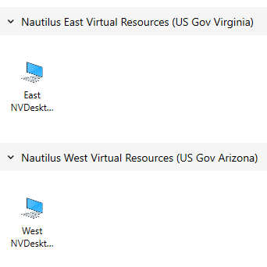Once installed, open the application and double click on the NVD East or NVD West
- 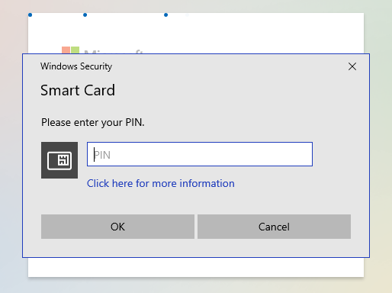Login to NVD using Flankspeed credentials (@us.navy.mil)
- 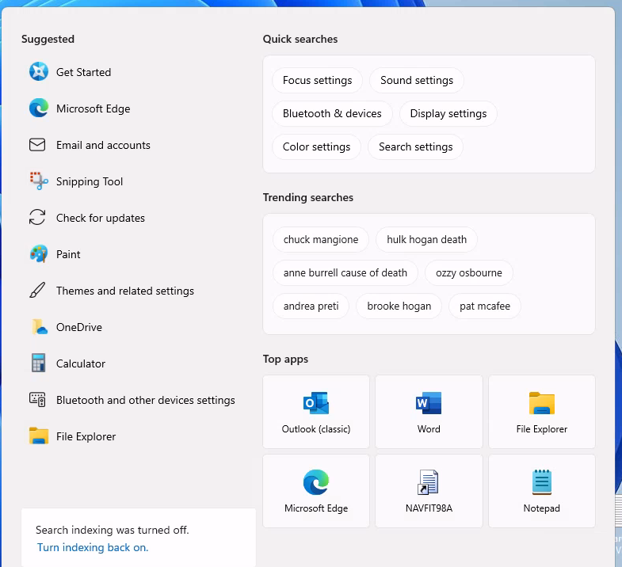Click the on the SEARCH block at the bottom of the screen to get the APP icons and click on the NAVFIT98A icon:
- IF NAVFIT98A is not listed -- type NAVFIT in the search block at the bottom of the screen and click Open
- 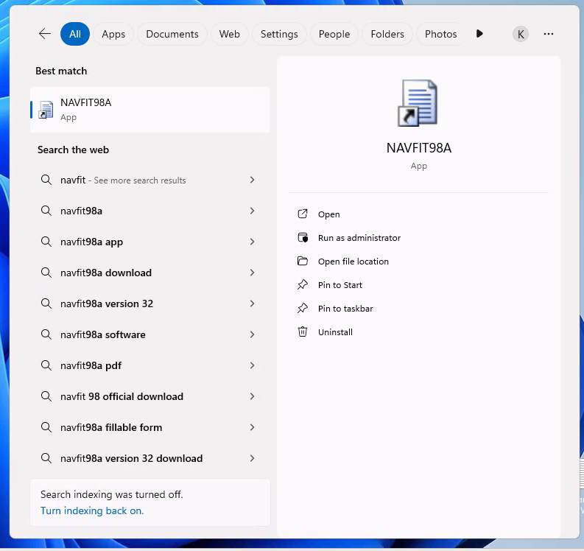Databases should be accessed/saved to the One Drive
- Create and draft performance evaluation IAW 1610.
- Reports can be printed as “.pdf” files, which can be emailed (following security mitigation issues) to computers with attached printers for hard copy signature.

How do I get access to the NAVFIT98A Program on a Government provided computer without downloading the software?
Answer:
- If a member needs a Nautilus Virtual Desktop (NVD) account, they should contact their ECH II Contract Technical Representative (CTR) for a FsAST operator to request a NVD account for that member. Once the account is assigned, the member receives an email from Nautilus/NVD with instructions on how to access the NVD account.
- If you do not know who your ECH II CTR is, please see the CTR lookup information on the NMCI Information Resource portal at: https://flankspeed.sharepoint-mil.us.mcas-gov.us/sites/NAVWAR_NMCI_Homeport/NMCI_Info/SitePages/CTRResources/CTRContact.aspx
- See the question about how to access the software through NVD

How do I download the NAVFIT98A Program on Non-NMCI, USMC, USA, USAF or other Government provided computers?
Answer:
- NAVFIT98A installation packages should only be downloaded by system administrators of systems that are not part of NMCI or Nautilus networks to make NAVFIT98A available to Navy users. System administrators can obtain the installation files from My Navy Portal (MNP).
- The USMC is or has deployed to their MCEN server
- The AirForce is or has deployed to their AFNET server
- DHA is or has Deployed to their Health network server
- The installation software will be housed on My Navy Portal for download; the Documentation will be house on the My Navy HR /Career Management web site.
- If approved as a hosting site, the installation software can be retrieved from SAILOR.

Which copy of the Installation package should I install?
Answer:
- For centrally managed software (like Software Center) the installation software will determine which copy of the software to install.
- For manual installations, the 32bit copy of NAVFIT98A should only be installed on systems with Office 2016 or lower and the 64bit copy of NAVFIT98A should only be installed on systems with Office 2019 or higher.
- For computers running Windows 7, Contact the MyNavy Career Center at (833) 833-6622 or via e-mail at askmncc@navy.mil.

Right after installing the software, I get the following error:
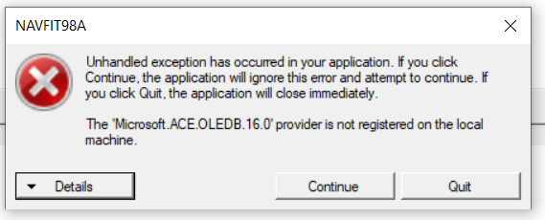
Answer 1:
- Open the Control Panel by searching for it in the Start menu.
- In the top-right corner, select Category View, then sort it by Small or Large Icons.
- Click on Configuration Manager.
- In the Configuration Manager Properties box, go to the Actions tab.
- Click on each action listed and then select Run Now to refresh the system.
- Navigate to the Configurations tab, then select Refresh and Evaluate.
- Wait up to 24 hours, then test NAVFIT98A to determine if the issue persists.
Answer 2 – If answer 1 doesn’t correct the problem:
- Close all Office products
- Open the Windows Start Menu
- Click on Windows Powershell
- Right Mouse over "Windows PowerShell system" option
- Mouse over More, then click "Run as administrator"
- Paste this to the command line: start-process "C:\Program Files\Microsoft Office 15\Clientx64\Officeclicktorun.exe" -ArgumentList "scenario=repair system=x64 culture=en-us repairtype=quickrepair displaylevel=false" -wait -PassThru
- Wait several minutes then enter “exit”.
- Reboot the system.
Answer 3 – If answer 2 doesn’t correct the problem:
- Contact the MyNavy Career Center at (833) 833-6622 or via e-mail at askmncc@navy.mil.

Right after installing the software, I get the following error:
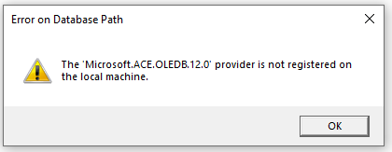Answer 1:
- Verify what version of Office you are using. You may have installed the wrong bit-ness copy of NAVFIT98A
- 32 Bit NAVFIT98A for Office 2016 and 64Bit NAVFIT98A for Office 2019 and above
Answer 2: If the error changes.
- If the popup message changed from OLEDB.12.0 to OLEDB.16.0, see the question about what to do when receiving that message.
Answer 3 – If answer 1 and 2 doesn’t correct the problem:
- Contact the MyNavy Career Center at (833) 833-6622 or via e-mail at askmncc@navy.mil.

Do I need to run the “NAVFIT98A Part 2 Access Database” from Software Center?
Answer
- no
- this option only installs or uninstalls the 32 bit Microsoft Access Database Engine, which only causes problems.

When I install the software or run the software, a popup box shows that says “.Net Framework v4.8.1 is needed”.
Answer 1:
- If you are running Windows 7, a Windows 7 compatible installation package can be requested via the MyNavy Career Center (MNCC) help desk at 1-833-330-MNCC.
Answer 2:
- Cancel the installation or exit from the program
- This will generally occur on older shipboard and SUBLAN systems.
- In the directory where the files were downloaded from DoD Safe, find the file “NDP48-x86-x64-AllOS-ENU.exe” and run it as Administrator
- Reboot the computer
Answer 3:
- Cancel the installation or exit from the program
- Download the .net Framework v4.8.1 installation package
- Unzip the downloaded file and find the file “NDP48-x86-x64-AllOS-ENU.exe”. run it as Administrator
- Reboot the computer
Answer 4 – when all else fails:
- Contact the MyNavy Career Center at (833) 833-6622 or via e-mail at askmncc@navy.mil.

Can I use an existing Database with this Version
Answer:
- If the database was created with any dated build of this version of the software, then Yes.
- If the database was created with a previous version of NAVFIT98A, it may not be used with this version. However, this version has a module that will convert all older databases to a new format that is compatible with this version. (there is no need to cycle through the Version changes, this module works with ALL previous versions).
- The instructions to convert the database is on the NAVFIT98A menu under “Help/How to…”

Why does the printed copy and NAVFIT98A program summary group average differ?
Answer:
- The calculations on the summary group average are being done in 2 places, once when the evaluation is created or changed and the second when printed. Make a change to one of the traits on the input screen to force the calculation to activate, save the information and then print the report. This should give the same information on the printed report.
- The previous build would print 0.00 as the summary group average on FitRep forms. Make sure the Help/About NAVFIT98 screen has a date newer than 29 May 2025

When I print the summary letter, I get an error “a folder must have a unique pay grade to generate a summary letter”. What is the problem?
Answer:
- The user has created multiple pay grades (block 2 of the Forms) in the same folder. The user should create all the reports within a Folder to have the same Grade and this will correct the problem.

The NAVFIT98A program windows are blank and the buttons are disabling on the main menu. How do I get the reports to show and the buttons on the main menu to enable?
Answer 1:
- From the menu click “File” then “Create Database”
- The NAVFIT98A Create database prompt should appear
- Pick a location for the database and enter a name for the Database
- Click “Save”
- The ROOT folder and the buttons should appear.
Answer 2:
- From the menu click “File” then “Open Database”
- The NAVFIT98A Open database prompt should appear
- Find the location where the database is stored and select it
- Click “Open”
- The folders, associated reports, and the buttons should appear.

How do I consolidate the reports into one folder?
Answer:
- A User can copy data from one folder to another by using the IMPORT Data function.
- Select the Folder (grouping) that the data needs to be copied to and press the Import Data Function
- A dialog box displays a list of database files to import from, select the same database that is currently open.
- An Import folder dialog box displays the Folder Structure of the database showing.
- Select either the folder or all the reports under a folder and press the Import button.
- Select the folder that the reports should have been copied to view them; they will still exist in the previous folder and probably should be deleted to avoid confusion.

What are the correct procedures when creating Fitness and Evaluation reports?
Answer:
- Select the Root Folder
- “Click “Create Folder” from the main menu
- Assign profile name
- Click “save”
- Select newly created Folder
- Click “Create FitRep” or “Create Chief Eval” or “Create Eval”

Cannot enter data in block 43 or 46. What is the problem?
Answer:
- The Auto Summary check box is checked
- Click “Edit Folder”
- Click the “Option Tab”
- Unchecked “Auto Summary”

How do I import or export a report with NAVFIT98A program?
Answer:
- Refer to the NAVFIT98A v33 user guide manual located on the MyNavyHr Career Management webpage (until it becomes available, the v30 guide can be used in the meantime)

How can a find out what version of NAVFIT98A that I am using?
Answer:
- Open the NAVFIT98A program
- Click on “Help” from the toolbar, then click “About NAVFIT98”; the version number and Build date will be displayed

Why do my reports have “NOT VALIDATED” at the top if the report?
Answer:
Note: this was turned off for this build until the validations could be verified as accurate.
- A new requirement for this version is that the report MUST be validated before it can be sent to KOFAX for use in Promotion Boards.
- On the main screen, in the Reports sections, the last column on the right will show “True” if it was validated and “False” if it was not
- A report listed as “False” will contain the “NOT VALIDATED” message at the top.
- A report listed as “True” will not contain the “NOT VALIDATED” message at the top and will be valid for signatures and submission to KOFAX.

When I print a Folder, why do some of the reports say “NOT VALIDATED” at the top and some do not?
Answer:
Note: this was turned off for this build until the validations could be verified as accurate.
- See the question on why “NOT VALIDATED” is on the report.

My report was listed as “True”. Why does it now it says “False”?
Answer:
- Every time the SAVE button is pressed, the report is changed to False, even if no changes are made.
- After saving, changes must be validated (click “Validate Report”) for the report to be identified again as “True”.

When I run the “Validate Folder” option, why do none of the reports show “TRUE”?
Answer
- The Validate Folder option only checks for differences between reports withing a grouping.
- The Validate Report function must be run on the individual report in order for it to be identified as “True”,

I can’t get NAVFIT98A v33 on my computer; What do I do?
Answer
- Blank fillable forms can be found on MyNavyHr:
https://www.mynavyhr.navy.mil/Career-Management/Performance-Evaluation/Software-Forms/
- This is an option for Navy Personnel struggling to get the NAVFIT98A software loaded on their computer until the software can be loaded.
- This is an option for Navy Personnel stationed anywhere that NAVFIT98A is either not approved or not accessible

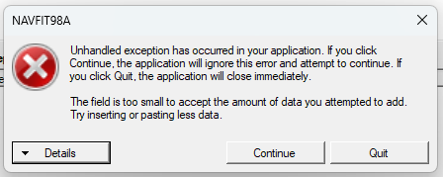When trying to convert a v32 file, why do I get the following Error?
Answer
- Check the Known Issues section

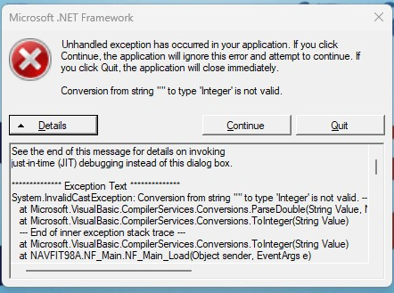Right after installing NAVFIT98A v33, why did I get this error when Opening the software?
Answer
This occurs because a database was still open when the previous version was uninstalled and the new version installed. The settings from the previous version still exist on the system and the new version of NAVFIT can’t find the database that was open.
- Press Continue
- Select File/Exit
- Open NAVFIT98A v33 again
- The error should not occur again.
- If the error persists:
  - Press Continue
  - Select File / Create Database
  - Follow the directions for creating a database
  - Select File / Exit
  - Open NAVFIT98A v33 Again
  - The error should not occur again

Are there any Known issues with NAVFIT98A V33?
Answer:
These are the known issues with NAVFIT98A v33:
Note: some of these issues were authorized to be corrected in production. If this error is still occurring, you may have an older copy of V33. Check with My Navy Hr Help Desk (MNCC) to find out the correct build number and date (listed in the Help/Help NAVFIT98A about in NAVFIT98)
- The Convert Database menu option throwing an Error.
  - NOTE: This was corrected in the 22 Aug 2025 build. Check the Help/About NAVFIT98A to determine the build date
  - When converting a v32 database file to v33, sometimes this error is thrown:
  - In V32, the Reporting Senior Address was a free form text field that allowed anything to be entered for an address. In v33, the address was broken down into its component parts so that the address format could be standardized like this:
    - Address1
    - Address2 (optional)
    - City, St, Zip
    - Phone (optional)
    - DSN (optional)
  - The free form text Address from v32 may not be compatible with the new database structure and will throw an error rejecting the entire database.
  - If the address can be corrected before upgrading to V33, that is preferable, but once upgraded, NPC has suggested the following steps to mitigate the issue because in some instances, even the properly formatted Zip code will cause a conversion error:
1. Save a copy of your old database.
2. Open the copy in Access.
3. Delete all data in the RSAddress field.
4. Follow the steps in NAVFIT98 v33 "Help" to Convert Database.
  - This is on the list for v34 correction.
- Connection to MyNavyHr not working
  - 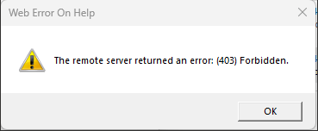In April 2025, the Help/MyNavyHr Help menu option started throwing this error
  - 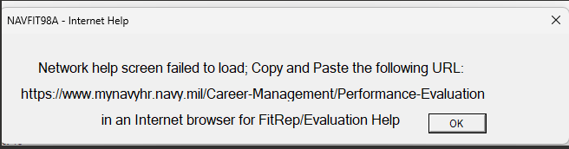If you press OK, it will provide another popup with the URL to get to the My Navy Hr/Career Management/Performance Evaluation web site
  - Copy the URL and paste it into a browser manually
- IsValidated field not updating after Report Validation
  - 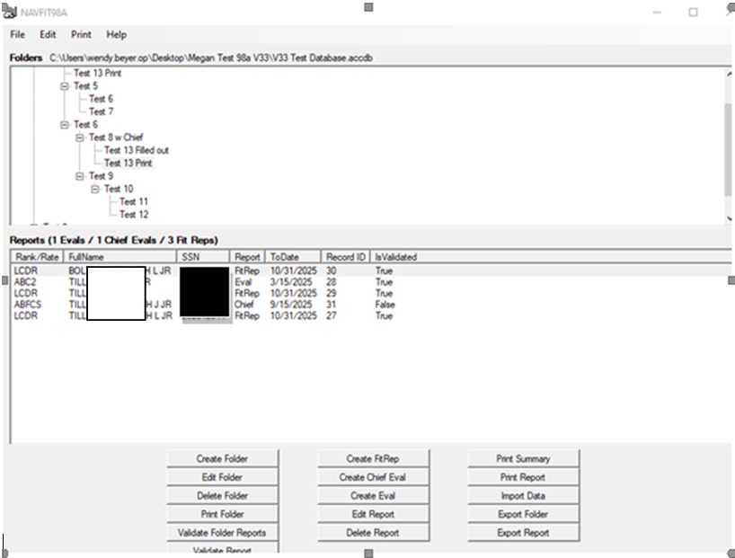After selecting a report on the main page and pressing the Validate Report button, the IsValidated field on the screen will not change values; this one is on the list for v34 correction (Note: the PII data displayed is not real)
  - The data was changed, it just didn’t get repopulated on the screen
  - Click on another folder header and then back on the folder header with the attached Reports; the IsValidated column will be updated.
- Group Summary Average printing zeros
  - NOTE: This was corrected in the 22 Aug 2025 build.
  - When printing an Eval or Fitrep, the group Summary Average will always print 0.0 even if the input screen has an actual number; this one is on the list for v34 correction.

Will this software work on a Shared Computer?
Answer:
- Yes.
- As a standalone application NAVFIT98A is available to anyone logged into the computer it is installed on.
- The database being used to store the evaluations is kept in the individual user’s Remote Profile
- For NVD, NAVFIT98A is installed on the server so that when a user logs into NVD, they Virtual Desktop contains a copy of the software.
- In the case of accessing through NVD, the Database will be on the individual user’s One Drive.

Will this software work with a Shared Database?
Answer:
- No.
- This software uses Microsoft Access as its Database Management System (DBMS), which is a single user application.
- The database can be housed in a shared location, but only one person can have it OPEN at any given time.

Is NAVFIT98A compatible with Windows 7?
Answer:
- No
- However, a Windows 7 compatible installation package can be requested via the MyNavy Career Center (MNCC) help desk at 1-833-330-MNCC.

I downloaded the software, and Windows Defender is reporting a Virus/Malware detection
Answer:
- On some platforms, the download of NAVFIT98 v33 may trigger a Microsoft Defender Antivirus (MDAV) alert. These alerts have been categorized by Media Malware Analysis (MMA) as benign. NCDOC Current Operations (CTG 1020.1) attests that it is safe for NAVFIT98 v33 to be available to the Navy.
- Run a Virus Scan on the specific file that MDAV alerted to and if nothing is found, resume the installation. Contact the MNCC if a second (different) alert is reported.

Why is “WO1” or Warrant Officer 1 listed as Not Valid in block 2?
Answer
- NOTE: This was corrected in the 22 Aug 2025 build.
- The input screens and 99 percent of the validations on the E1-E6 Evaluations and W1-O10 FitReps were not changed for this update.
- Until a requirement change is received, WO will have to be used since WO and WO1 are essentially the same Rank.
- This is on the list for v34 correction.

Why does block 33-39 change to NOB when I check block 16(NOB)?
Answer
- This functionality was introduced in V31 because the validation in V30 said that block 33-39 had to be marked NOB if Block 16 was NOB
- It didn’t make sense to force the user to do something that could be automated even if it seemingly contradicts the Eval Manual/Navy Policy.

Why does the EP/MP numbers fail validation on a large grouping of Reports?
Answer
- On a large group (170 evals) the validation tool’s math is off. I get a failed validation saying the EP/MP numbers are not accurate. 170 E6 evals should be 34 EP, 68 MP, 68 P, 20% EP, 40% MP and 60% EP+MP combined. That is how we have the group marked on the reports, however the validation tool says that we are wrong. This fails validation, resulting in “not validated” on the printed eval.
- Possibly the numbers are off because the GRADES (block 2) between these records are different. The requirement to include the Grade within the grouping was Identified in March 2025
- NOTE: there was a bug on one of the validations that caused a rejection to occur. This was corrected in the 22 Aug 2025 build.

Why do some real Legitimate Warfare devices fail validation?
Answer
- The input screens and 99 percent of the validations on the E1-E6 Evaluations and W1-O10 FitReps were not changed for this update.
- User reported:
“Many real / legitimate warfare devices are not recognized by the validation tool. I checked all the warfare devices / abbreviations I could find in the Navy Uniform Regulations. These ones FAIL validation and give “not validated” on the printed eval: SWCC, IW (E1-E6 & W2-O6 reports only), MCD, IUSS, EWS (used to be EOD). The biggest deal from this list I would say is IW on the E1-E6 and W2-O6 reports, and the SWCC one on all reports. SWCC is the major qual for the SB rating and IW is a major qual for many officers and enlisted.” NOTE: This has been corrected for this Build
- The original warfare devices were hard coded in the software and the validations were not enforced beyond reporting that the device was invalid.
- The IW was introduced in April 2025 but the validation on the Folder Validation was not updated. NOTE: This was corrected in the 22 Aug 2025 build.
- Requirements need to be changed to identify the valid values and the occasions when they should be validated.

Why does the Validate Report function give different results from the Validate Folder Reports function?
Answer
- The “Validate Report” function gives different results than the “Validate Folder Reports” function. I saw this when validating a folder of E8 evals, one report had “IW” in block 3 as a warfare designator. The “Validate Report” function gave a successful validation. The “Validate Folder Reports” function gave a failure for “invalid warfare designator “IW”.
- The Validate Report and Validate Folder modules should give different results as they validate different aspects of the Evaluation Program, however, the IW validation on the Validate Folder module could have been missed when IW was introduced as a valid value.

Why does the IsValidated column not change on the Main screen when the report is validated?
Answer
- See Known Issues section

Why does an error occur when closing and opening a report after a failed validation?
Answer
- Not every time, but sometimes, reports that contain a validation failure item (like when the warfare designators fail), once saved, closed, and reopened, an unhandled exception error is thrown.
- Remove or change the failed info and this error goes away.
- Issues like this should be reported to Pers-32 for inclusion in the next version number software updates; this error is sporadic and dependent upon the system configuration and date being used.

Why am I getting this error:
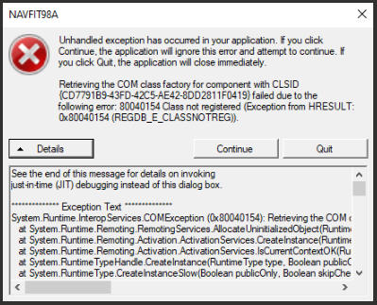
Answer
- This generally occurs when the wrong bit version of NAVFIT98 is installed
- See the Installation Instructions to determine which bit version of NAVFIT98 should have been installed.

How do I print from NVD?
Answer
- Users can print to a .PDF file, save to their OneDrive, and then:
  - Access their OneDrive from an NMCI device and print the .PDF file
  - Send the .PDF via encrypted email from NVD Outlook to someone on a CAC secured Government Computer that can print the .PDF file
  - Send the .PDF or
- Users can send the NAVFIT98A Access Databases via DOD SAFE to someone on the NMCI side to print the report from NAVFIT98A

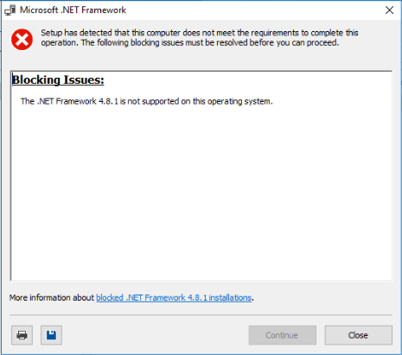What do I do when I get this error?
Answer
- This occurs on Windows7 computers, contact the MyNavy Career Center (MNCC) help desk at 1-833-330-MNCC and ask for a Windows7 compatible version of NAVFIT98A.
- This could occur on Windows 10 systems that are not using the latest build; contact the MyNavy Career Center (MNCC) help desk at 1-833-330-MNCC and report the Window Version and Build number.

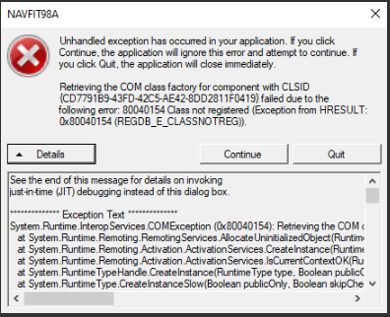Why am I getting this error?
Answer
- This occurs when the wrong Bit version of NAVFIT98A is installed.

Summary:
Users with NMCI assets will be able to download and install NAVFIT98A v33 from the Office 365 Software Center or can access it via Nautilus Virtual Desktop/Nautilus. Users should contact the MyNavy Career Center (MNCC) help desk at 1-833-330-MNCC. Any issues the helpdesk(s) can’t resolve will be routed for higher-level support. Joint or other service commands have been provided with instructions on how to download or access using their service-specific IT platforms.

