Navfit98 v2.2.0.33 Installation Build Instructions
This set of instructions is for System and Network owners to install the NAVFIT98 software on their networks so that Individual users can either download and install the software manually themselves or access the installed application directly from the Network. This also documents how individuals can install the software on their computers if they have Admin privileges. Be sure to READ TO THE END OF THE DOCUMENT.

IMPORTANT:
Before Installing NAVFIT98 V33, check the Reporting Senior Address on every report in the NAVFIT98 V32 database (even historical reports). The Address should be listed as a standard address format otherwise when trying to Convert the v32 database to the v33 format, the application may crash:
- Address1
- Address1
- City, ST Zip
- Phone Number
- DSN
Also, before installing NAVFIT98 V33, open NAVFIT98 v32 and close any open database using File/Close Database

System owner or a lone member
PMW 240 has a list of people that were sent a copy of NAVFIT98 v32. Immediately following the N1 approval to deploy the software, everyone on that list will be sent a DoD Safe email with a link to download the software. Following that initial rollout, anyone that needs the software will have the option to:
  - request the software through MyNavyHR Help Desk (MNCC)
  - download directly from MyNavyPortal
- Download all the files into a temporary working folder (either all at once or one at a time).
- The file from DoD Safe will be a .zip file which will need to be extracted to the above-mentioned temporary working folder.
- The extracted files (NAVFIT98Av33 Installation Package nn Bit.ZIP) will also need to be extracted. NOTE: Some non-Navy systems do not have WinZip and the encryption method is not compatible with Navy systems, so the file received with be NAVFIT98Av33 Installation Packages.ZIP and will not be encrypted or password protected (there is no PII data in the file to protect).
- The Extracted folders (32-bit and 64-bit) will contain the installation packages. Only one installation package should be installed depending on which version of Office is installed; Office 2016 and prior gets the 32-bit package, Office 2019 and after gets the 64-bit package.
Note:Windows7 systems will need to request a compatible copy through MyNavyHr Help Desk.
- Previous versions of NAVFIT98 need to be uninstalled, especially any existing copy of THIS version of the software.
- The installation package is to be run as an Administrator so that the software instance is available for All Users.
- Additional .zip files with additional Microsoft software will be sent along with this software just in case it is needed by the receiving system.
  - MicrosoftOffice 32 Bit.zip and MicrosoftOffice 32 Bit.zip
This is the Microsoft Access Database Engine v2016 driver. This software may be needed on certain computer systems where the Windows and Office products do not have a clear method for third party software (like NAVFIT98) to access the Microsoft Office products. This is not needed for every computer; the FAQ document explains when it is needed.
  - NDP481-x86-x64-Allos-ENU.zip
This is the .net Framework v4.8.1 software that the NAVFIT98 software uses to get the most up-to-date .dll files from Microsoft related to .net Framework v4. This is not needed on every computer but will be needed on many of the Navy systems; the FAQ document explains when it is needed. Windows 7 systems are not compatible with this .net framework version

Manual Local Computer Installation
- The software can be installed directly on a Local computer
- From the control Panel/ Programs and Features Uninstall any copy of NAVFIT98.
- Even though 2 installation packages are received, only one needs to be installed.
  - The computer contains Office 2019, Office 2022, Office 2024, or Office 365
If the computer system has any of these Office versions installed, then only the 64 bit version of NAVFIT98 V33 should be installed.
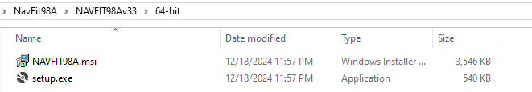
  - The computer contains Office 2016 or before
If the computer system has Office 2016 or before installed, then only the 32 bit version of NAVFIT98 V33 should be installed.
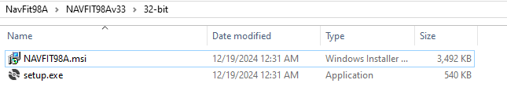
- Run the setup.exe file associated with the bit-ness of the software. The installation package needs to be run as Administrator so that it will install correctly for all users
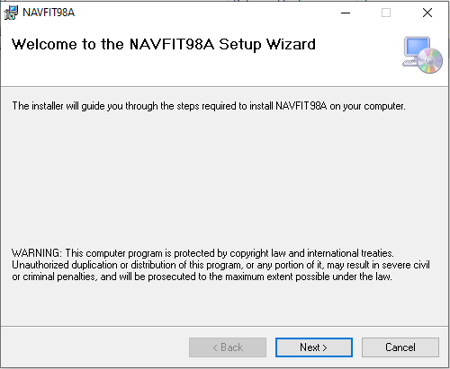
  - The splash page shows up first… click Next

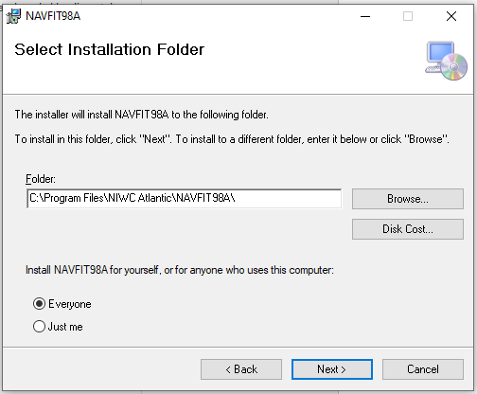
  - The folder selection prompt is next (the folder will either be C:\Program Files (x86)\NIWC Atlantic\NAVFIT98A\ or C:\Program Files\NIWC Atlantic\NAVFIT98A\):
  - Make sure the radial button for Everyone is turned on
  - Press next and finish as they occur until the software is installed.

Software Center
- For those computers attached to the NMCI network NAVFIT98 is hosted on Software Center and can be installed from there.
- Current users should see this entry:
- Click that entry to get the following screen:
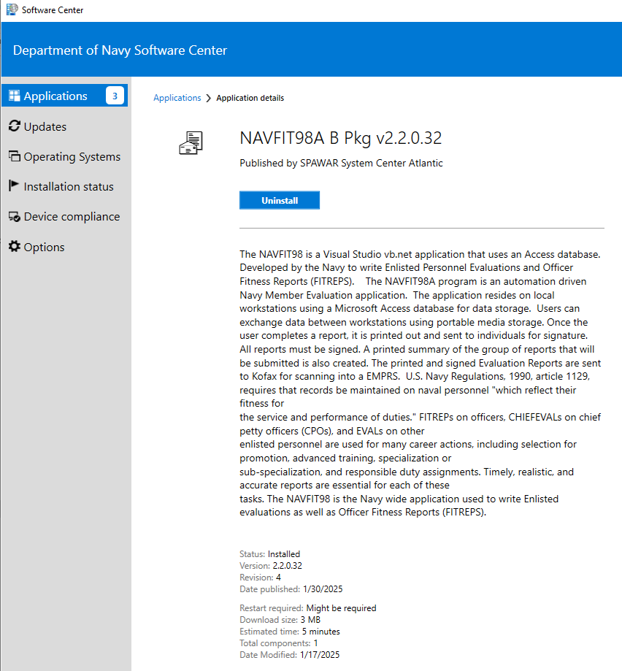
- This will uninstall NAVFIT98 v2.2.0.32; NAVFIT98 v33 will not install otherwise
- Software Center should have the following information for NAVFIT98A V2.2.0.33:
NAVFIT98A is a Visual Studio VB.Net application that uses an Access Database for Data storage. Developed by the Navy to write Enlisted Personnel Evaluations (EVALS) and Officer Fitness Reports (FITREPS). This application is the current Navy standard.
Version: 2.2.0.33
Revision: 7
Date Published: 5/30/2025
Restart Required: Might be required
Download size: 2 MB
Estimated time: 5 minutes
Total components: 1
Date Modified: 5/29/2025
- Once the software is established on Software Center , test by having someone install NAVFIT98 from Software center and then run the software from the menu. Try creating a database (File/Create Database). Try Adding an enlisted Rating (Edit/Lookup Tables/RankRate).
- This will be the last version deployed to NMCI before everyone is converted to NAUTILUS. This software has some known bugs that were corrected by a subsequent NAVFIT98A V33 build.

NVD
For users without access to NMCI, but can connect to NVD using their CAC, the NAVFIT98 software is already loaded on the network and available for use.
- Connect to NVD and Login (both East and West are usuable)
- In the bottom of the virtual desktop, enter NAVFIT
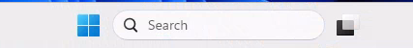
- Click Open to access the software
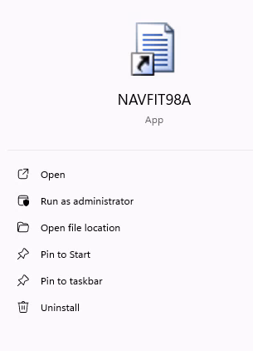
- When Creating a Database, the database must be saved on the One-Drive.

Nautilus Endpoint Device
This works similar to installing from Software Center, but it comes from Company Portal

My Navy Portal
This works like downloading from DoD Safe and Installing manually on a local computer
Note: On some platforms, the download of NAVFIT98 v33 will trigger a Microsoft Defender Antivirus (MDAV) alert. These alerts have been categorized by Media Malware Analysis (MMA) as benign. NCDOC Current Operations (CTG 1020.1) assesses that it is safe for NAVFIT98 v33 to be available to the Navy.
- Run a Virus Scan on the specific file that MDAV alerted to and if nothing is found, resume the installation. Contact the MNCC if a second (different) alert is reported.

Additional Software
Additional software is included for those special cases where it is needed. This software DOES NOT have to be installed to get NAVFIT98 to work; it only needs to be installed if the NAVFIT98 v33 throws certain errors. This is only needed where NaVFIT98 was manually installed on a computer:
- .net Framework v4.8.1
  - Windows 7 is not compatible with .net Framework v4.8.1; Contact the MyNavy Career Center at (833) 833-6622 or via e-mail at askmncc@navy.mil to get a Windows 7 compatible version of NAVFIT98A.
  - Certain older systems did not come with .net Framework v4.8.1. When Navfit98 v33 runs, it will throw a popup box that indicates that this software is needed.
  - When that occurs, close Navfit98 and run the NDP481-x86-x64-AllOS-ENU.exe as an administrator to install the .net Framework v4.8.1 software.
  - Reboot the computer and try running NAVFIT98 again.
- Microsoft Access Database Engine v2016 Redistributable
  - Certain ships and external systems will throw an error after NaVFIT98 v33 is installed. That error will either look like this or it will say Microsoft.ACE.OLEDB.12
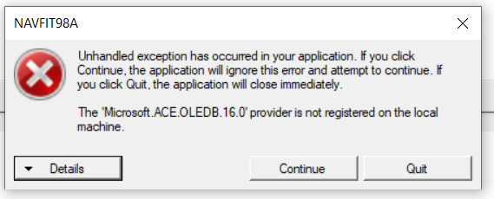
  - If you installed the 32 bit version of NAVFIT98a V33, double click on the MicrosoftAccessDatabaseEngine2016Redistributable.bat file to install the 32 bit Access Driver; it will ask you to login as an Administrator.
  - If you installed the 64 bit version of NAVFIT98a V33, double click on the MicrosoftAccessDatabaseEngine2016Redistributable_x64.bat file to install the 64 bit Access Driver; it will ask you to login as an Administrator.

